Richmond Swims
Richmond Sailfish
Richmond Plunge Masters
USA Swimming and USMS
10th Annuall Keller Cove Open Water Swim for Kids Sake
September 21, 2019 Keller Cove, Miller/Knox Regional Shoreline, Richmond, CA

SANCTION: Dual sanctioned open water meet, held under USMS Sanction No. 389-W006 and USA Swimming Sanction No OW-19-003. In granting this sanction it is understood and agreed that USMS and USA Swimming shall be free from any liabilities or claims for damages arising by reason of injuries to anyone during the conduct of the event.

NOTICE: By entering this meet, the athlete or his/her guardian consents to the publication, via electronic, print or other media, information and/or imagery related to their participation at this meet. Such information and imagery may include, but is not limited to, photographs, video, web casting, television, psych sheets and live meet results. Official results will be posted on the Internet at http://www.bigskyendurancesports.com .

REGISTRATION INFORMATION: Swimmers can register online at https://endurancecui.active.com/event-reg/select-race?e=64286551
Or swimmers can mail in the paper entry form in this document. Same day registration is available until the 300 swimmer cap is met.
Online registration will close on September 19, 2019 at 11:59 pm.

USE OF AUDIO AND VISUAL: Use of any audio or visual recording devices, including but not limited to film and digital cameras, cell phones and tablets, and Google Glass is not permitted in changing areas, rest rooms or locker rooms. Violation of this recording prohibition may result in ejection from the facility by the Meet Referee or his/her designee.

MEET PERSONNEL:
Meet Referee: Markus Daene
Meet Directors: USMS Norm Hantzsche; nhantzsche@questaec.com
USAS Ron Taylor; rntylr@gmail.com
Race Safety officer: Kaitlin Harris; pandakaitlin@gmail.com
Directio
LOCATION: Keller Beach, Miller/Knox Regional Shoreline, Richmond, CA

DIRECTIONS: Keller Beach is located at the intersection of Western Dr. and Dornan Dr. in Point Richmond, adjacent to the south portal of the Dornan Dr. Tunnel. From Highway 580, take the Canal Blvd exit and turn south; turn right at W. Cutting Blvd; turn left at Dornan Dr./S. Garrard and proceed past “The Plunge” through the tunnel. Keller Beach is on the right upon exiting the south side of the tunnel.

CONDITIONS: The expected water temperature: 63-67 degrees. The event will be a beach start and beach finish. The course is patrolled by safety craft and is closed to all other craft. Participants should be adequately trained for open water swims of this length. Previous experience in similar water conditions is highly recommended.

ABANDONMENT: If local condition or safety concerns lead to abandonment during the race, athletes are required to follow the instruction from lifeguards and other meet supporting personnel. In such a case, the event shall be considered complete. The final placings of all athletes shall be determined by the Meet Referee. Situations not covered shall be determined by the Meet Committee.

TIME:
- Swimmer Check-in: 7:30 am – 9:00 am
- Warm up 8:15 am – 9:00 am
- Welcome and Introductions: 9:00 am – 9:10 am
- Race Instructions ½ -mile (Mandatory) 9:10 am – 9:25 am
- ½ -mile Swim 9:30 am – 10:15 am
- Race Instructions – 1 & 2 mile 10:15 am – 10:25 am
- 1 & 2-mile Swims (Mandatory): 10:30 am – 12:30 pm

RACE CUTOFF TIMES: USMS Athletes will have 45 minutes from the start of their wave to complete the ½ mile race. USAS athletes will have no less than 30 minutes after the first swimmer in their age group finishes in accordance with USA swimming rule 701.2.7. The 2 mile cut off time is 2 hours, and 1 hours and 45 minutes for the 1 mile.

Sequencing and Wave Starts:
- 1/2-mile. The ½-mile swim, which will be run first as a separate event (<150 participants), will have two waves, with an approximate 5-minute spacing between waves - Masters swimmers first, USA swimmers second.
- 1 and 2-mile. The 1-mile and 2-mile swims will be run concurrently, starting about 15 minutes after conclusion of the ½-mile swim. The waves will start about 5 minutes apart, with sequencing as follows: (a) all 2-milers (Masters only); (b) 1-miler (Masters, 39 and under); (c) 1-milers (Masters, 40 and older); (d) 1-milers (USA youth). No wave will have more than 150 swimmers.

GENERAL RULES:
- For USAS athletes, current USA Swimming rules and warm-up procedures will govern the meet. A copy of these procedures will be posted at the Clerk-of-Course.
- For USMS athletes, current USMS rules will govern the meet.
- Events will start in waves, depending on the number of entries. The waves will be denoted by different color caps. USAS athletes and USMS swimmers will not swim in the same waves.
- All athletes ages 12 and under should complete competition within four (4) hours. USA swimmers can swim in only 1 (one)
- Entries will be accepted until the number of splashes exceeds the number of athletes that can be safely accommodated. Approximately 300 athletes.
- All Officials must be current on their background check, athlete protection training and concussion training according to USAS standards.
- All USAS coaches and deck officials must wear their USA Swimming membership cards in a visible manner.
- There will be a safety meeting before the start of races. The safety meeting is mandatory to all participants.
- Athletes who have not finished by the cutoff time for the event will be disqualified.
- All races are unescorted swims. All watercrafts, including boats, paddle boards or kayaks are prohibited on, at or near the race course during the time of the event, except for those used by the host team for conducting the meet or lifeguard operations.
- All athletes must wear the provided swim cap. If two caps are worn, the provided cap has to be on top.
- The timing system will be electronic timing with chips that must be worn at the ankle. Timing chips will be given out at registration and must be returned after the race. Athletes not returning or losing the timing chip will be charged with a replacement cost of $25.
- Disqualified athletes must leave the water immediately.
- Warm up and warm down will be allowed near the beach on the north side of the beach. Warm up will be allowed between 8:15-9am. Swimmers can not swim out past any buoys and can only be in the water once the lifeguards are in position and warm up is announced.

UNACCOMPANIED ATHLETES: Any USA-S athlete-member competing at the meet must be accompanied by a USA Swimming member-coach for the purposes of athlete supervision during warm-up, competition and warm-down. If a coach-member of the athlete’s USA-S Club does not attend the meet to serve in said supervisory capacity, it is the responsibility of the athlete or the athlete’s legal guardian to arrange for supervision by a USA-S member-coach. The Meet Director or Meet Referee may assist the athlete in making arrangements for such supervision; however, it is recommended that such arrangements be made in advance of the meet by the athlete’s USA-S Club Member-Coach.

RESTRICTIONS:
- Smoking and the use of other tobacco products is prohibited on the pool deck, in the locker rooms, in spectator seating, on standing areas and in all areas used by athletes, during the meet and during warm-up periods.
- Sale and use of alcoholic beverages are prohibited in all areas of the meet venue.
- No glass containers are allowed in the meet venue.
- All shelters must be properly secured.
- Destructive devices, to include but not limited to, explosive devices and equipment, firearms (open or concealed), blades, knives, mace, stun guns and blunt objects are strictly prohibited in the swimming facility and its surrounding areas. If observed, the Meet Referee or his/her designee may ask that these devices be stored safely away from the public or removed from the facility. Noncompliance may result in the reporting to law enforcement authorities and ejection from the facility. Law enforcement officers (LEO) are exempt per applicable laws.
- Operation of a drone, or any other flying apparatus, is prohibited at Miller/Knox Regional Shoreline and in particular over the venue (race course, athlete/coach areas, spectator areas and open ceiling locker rooms) any time athletes, coaches, officials and/or spectators are present.
- In the event that the combined air and water temperatures do not meet the USA rule 702.2 combined temperature a 50% refund will be offered to all USA swimmers requesting a refund.

ADDITIONAL RESTRICTIONS for USAS Athletes:

- Deck Changes are prohibited. Restrooms facilities for changing are available at Keller Beach plus changing cabanas will also be provided.
- Finger and toe nails should be neatly trimmed and not extend past the finger/toe, in order to prevent injury to others. Race Officials may require nail trimming in order to compete.
- USA Swimming rule 701.1.2. For open water swimming competitions in water with temperature below 20°C (68°F), men and women may use either swimsuits or wetsuits. When the water temperature is below 18ºC (64.4ºF), the use of wetsuits is compulsory.

ELIGIBILTY:

- Athletes must be current members of USA-S or USMS. One-event registration covering the whole meet is available for USMS ($27) athletes. This can be found on-line and on race day.
- Athletes that hold a USMS and a USA Swimming registration, must select only one organization with which to compete for the entire meet.
- USAS Athletes must be current members of USA-S and enter their name and registration number on the meet entry cards as they are shown on their Registration Card. If this is not done, it may be difficult to match the athlete with the registration and times database. The meet host will check all athlete registrations against the SWIMS database and if not found to be registered, the Meet Director shall accept the registration at the meet (a $10 surcharge will be added to the regular registration fee). Duplicate registrations will be refunded by mail.
- USAS athletes 10 and under must enter in the ½ mile swim. Swimmers 11 and over may enter in either the ½ mile or 1 mile swim.
- USAS athletes of age 8 and older are eligible to participate in this meet.
- USMS swimmers may compete in the ½ mile, one mile, or two mile swim individually. Swimmers can also swim the ½ mile and 1 mile together. Swimmers can not enter the ½ mile and 2 mile swims.
- Entries with "NO TIME" will be ACCEPTED.
- Disabled athletes are welcome to attend this meet and should contact the Meet Director or Meet Referee regarding any special accommodations on entry times and seeding per Pacific Swimming or USMS policy.
- The age for USMS athletes shall be determined by the age of the athlete on December 31 of the year of competition, except for 18-year-olds, who must be 18 on the day that they swim.
- For USAS, the athlete’s age will be the age of the athlete on the first day of the meet.

ENTRY FEES:
USA Swimming:

Online or postmarked by: |  | Single Event  (½ mile or 1 mile)
Early | 09/9/19 | $30.00
Regular | 09/15/19 | $35.00
Last Minute | 09/19/19 | $40.00
Race Day | 09/21/19 | $50.00

USMS:
Online or postmarked by: |  | Single Event  (½ mile, 1 mile or 2 mile) | Two Events  (½ mile + 1 mile)
Early | 09/09/19 | $50.00 | $65.00
Regular | 09/15/19 | $55.00 | $70.00
Last Minute | 09/19/19 | $60.00 | $75.00
Race Day | 09/21/19 | $70.00 | $85.00

CHECK-IN: The meet will be deck seeded. Athletes must check-in at the Clerk-of-Course. Registration is open on Saturday from 7:30 am to 9 am. Athletes who do not check in will not be seeded and will not be allowed to compete in the event.

SCRATCHES: Any athletes not reporting for or competing in the race that they have checked in for shall not be penalized.

AWARDS: Ribbons

- USA-S: ½ and 1-mile swims; top 3 places by 8 and under, 9-10,11-12, 13-14, 15-16, 17-18 age groups, plus an 19 and over division; Boys & Girls

- Masters Non-Wetsuit Division: ½, 1 and 2-mile swims; top 3 places in each 5-yr age group; Men & Women
- Masters Wetsuit Division: ½, 1 and 2-mile swims; top 3 places 18-39, and 40+; Men & Women
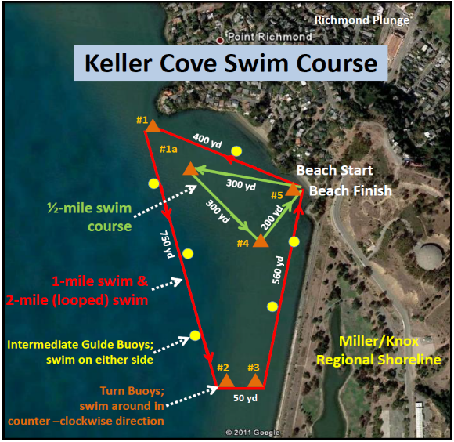
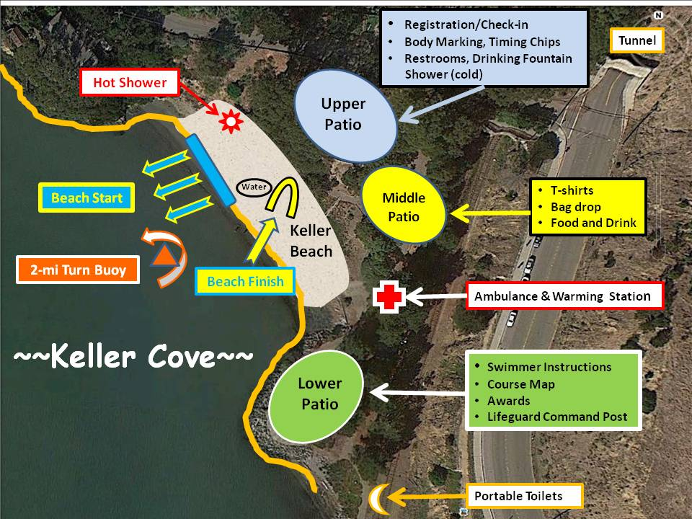
(Note: All Masters swims are eligible for Pacific Masters Open Water Points Competition)

Entry Form

10th Annual Keller Cove Swim for Kids’ Sake – Saturday, September 21, 2019
Keller Beach, Miller/Knox Regional Shoreline, Richmond, California

Sanctioned by Pacific Masters Swimming for USMS, Inc. No. 389-W006 USA Swimming/PC Sanction No. ______

Last Name: |  |  |  |  | First Name: |  |  |  |  |  |  |  | Circle Gender: M F
Street Address: |  |  |  |  | City: |  |  |  |  | State: |  |  | Zip:
Phone:  ( ) |  | Email: |  |  |  |  |  |  |  | Birth Date: |  |  | Age on Race Day:
Race Distance and Division (Circle One Only):
Swimmer Category
Masters – Category 1, Non-Wetsuit |  |  |  | ½ mile only |  |  |  | ½ mile + 1 mile |  |  | 1 mile only |  |  | 2 mile only
Masters – Category 2, Wetsuit |  |  |  | ½ mile only |  |  |  | ½ mile + 1 mile |  |  | 1 mile only |  |  | 2-mile only
USA Youth (with or without wetsuit) |  |  |  | ½ mile only |  |  |  |  |  |  | 1 mile only
Club Affiliation: |  |  |  |  |  | Club Initials: |  |  |  |  |  | USMS/USA-S #:
Postmarked on or before: | USA Youth  Entry Fees  ½ or 1-mile swim |  | Masters Entry Fees |  |  |  |  |  | Select T-Shirts Size(s):  Adult Men’s: S__ M__ L__ XL __  Pre-Reg Total T-Shirts: ____ x $15 each =_____  Race Day Total T-shirts: ____ x $20 each =_____
Postmarked on or before: |  |  | Single Swim  (½, 1, or 2-mile) |  |  |  | ½ + 1-mile
9/10/19:  9/15/19:  9/19/19:  Race Day: | $30 ___  $35 ___  $40 ___  $50 ___ |  | $50 ___  $55 ___  $60 ___  $70 ___ |  |  |  | $65 ___  $70 ___  $75 ___  $85 ___
Additional one event (OEVT) registration for non-USMS entrants  to be paid on Race Day at Registration: $27 |  |  |  |  |  |  |  |  | Total Amount Enclosed: $_______

Make checks payable to: “Richmond Swims”
Mail entry form along with check and photocopy of USMS or USA-S membership card to:
Richmond Plunge Masters, c/o Richmond Swims, P.O. Box 70952 Richmond, CA 94807

Membership in US Masters Swimming (adults) or USA Swimming (youth) is required to participate in this event for liability insurance purposes. To register with USMS, see the USMS website: http://www.usms.org/reg. You may also obtain One Event USMS membership on race day for a fee of $27, paid at Registration. Wearing the provided swim caps is mandatory. Fins, pull buoys or other swimming devices are not allowed. Check-in and race-day registration is from 7:30 am to 9:00 am, Saturday, September 21, 2019 at Keller Beach for all races.
RACE DAY ENTRY - STAFF AREA ONLY
Payment Received: Cash $ ________ Check $ ________ Check #: ________
PLEASE READ CAREFULLY AND SIGN
“PARTICIPANT WAIVER AND RELEASE OF LIABILITY,
ASSUMPTION OF RISK AND INDEMNITY AGREEMENT”
ON REVERSE SIDE OF THIS PAGE
 PARTICIPANT WAIVER AND RELEASE OF LIABILITY,
ASSUMPTION OF RISK AND INDEMNITY AGREEMENT
For and in consideration of United States Masters Swimming, Inc. (“USMS”) allowing me, the undersigned, to participate in any USMS sanctioned or approved activity, including swimming camps, clinics, and exhibitions; learn-to-swim programs; swimming tryouts; fitness and training programs (including dryland training); swim practices and workouts (for both pool and open water); pool meets; open water competitions; local, regional, and national competitions and championships (both pool and open water); and related activities (“Event” or “Events”); I, for myself, and on behalf of my spouse, children, heirs and next of kin, and any legal and personal representatives, executors, administrators, successors, and assigns, hereby agree to and make the following contractual representations pursuant to this Waiver and Release of Liability, Assumption of Risk and Indemnity Agreement (the “Agreement”);
- I hereby certify and represent that (i) I am in good health and in proper physical condition to participate in the Events; and (ii) I have not been advised of any medical conditions that would impair my ability to safely participate in the Events. I agree that it is my sole responsibility to determine whether I am sufficiently fit and healthy enough to participate in the Events.

- I acknowledge the inherent risks associated with the sport of swimming. I understand that my participation involves risks and dangers, which include, without limitation, the potential for serious bodily injury, sickness and disease, permanent disability, paralysis and death (from drowning or other causes); loss of or damage to personal property and equipment; exposure to extreme conditions and circumstances; accidents involving other participants, event staff, volunteers or spectators; contact or collision with natural or manmade objects; dangers arising from adverse weather conditions; imperfect water conditions; water and surface hazards; facility issues; equipment failure; inadequate safety measures; participants of varying skill levels; situations beyond the immediate control of the Event organizers; and other undefined, not readily foreseeable and presently unknown risks and dangers (“Risks”). I understand that these Risks may be caused in whole or in part by my own actions or inactions, the actions or inactions of others participating in the Events, or the negligent acts or omissions of the Released Parties defined below, and I hereby expressly assume all such Risks and responsibility for any damages, liabilities, losses or expenses that I incur as a result of my participation in any Events.

- I agree to be familiar with and to abide by the Rules and Regulations established by USMS, including any safety regulations. I accept sole responsibility for my own conduct and actions while participating in the Events.

- I hereby Release, Waive and Covenant Not to Sue, and further agree to Indemnify, Defend and Hold Harmless the following parties: USMS, its members, clubs, workout groups, event hosts, employees, and volunteers (including, but not limited to, event directors, coaches, officials, judges, timers, safety marshals, lifeguards, and support boat owners and operators); the USMS Swimming Saves Lives Foundation; USMS Local Masters Swimming Committees (LMSCs); the Event organizers and promoters, sponsors and advertisers; pool facility, lake and property owners or operators hosting the Events; law enforcement agencies and other public entities providing support for the Events; and each of their respective parent, subsidiary and affiliated companies, officers, directors, partners, shareholders, members, agents, employees, and volunteers (individually and collectively, the “Released Parties”), with respect to any liability, claim(s), demand(s), cause(s) of action, damage(s), loss or expense (including court costs and reasonable attorneys’ fees) of any kind or nature (“Liability”) which may arise out of, result from, or relate in any way to my participation in the Events, including claims for Liability caused in whole or in part by the negligent acts or omissions of the Released Parties.

- I further agree that if, despite this Agreement, I, or anyone on my behalf, makes a claim for Liability against any of the Released Parties, I will indemnify, defend and hold harmless each of the Released Parties from any such Liabilities which any may be incurred as the result of such claim.

I hereby warrant that I am of legal age and competent to enter into this Agreement, that I have read this Agreement carefully, understand its terms and conditions, acknowledge that I will be giving up substantial legal rights by signing it (including the rights of my spouse, children, heirs and next of kin, and any legal and personal representatives, executors, administrators, successors, and assigns), acknowledge that I have signed this Agreement without any inducement, assurance, or guarantee, and intend for my signature to serve as confirmation of my complete and unconditional acceptance of the terms, conditions and provisions of this Agreement. This Agreement represents the complete understanding between the parties regarding these issues and no oral representations, statements, or inducements have been made apart from this Agreement. If any provision of this Agreement is held to be unlawful, void, or for any reason unenforceable, then that provision shall be deemed severable from this Agreement and shall not affect the validity and enforceability of any remaining provisions.
Last Name | First Name | MI | Sex (circle)  M F |  | Date of Birth (mm/dd/yy)
Street Address, City, State, Zip

Signature of Participant |  |  |  | Date Signed

